Apache Kafka – Word Count

Objective
To understand and implement a basic Apache Kafka messaging system by setting up Zookeeper and Kafka server, creating a topic, and demonstrating communication between a producer and a consumer. This helps in learning how real-time data streaming works using distributed systems.

Tools Required
- Apache Kafka
- Zookeeper
- Java
- Microsoft Azure Lab Environment (Virtual Machine / Cloud Setup)
- Terminal / Command Prompt
FLow Diagram
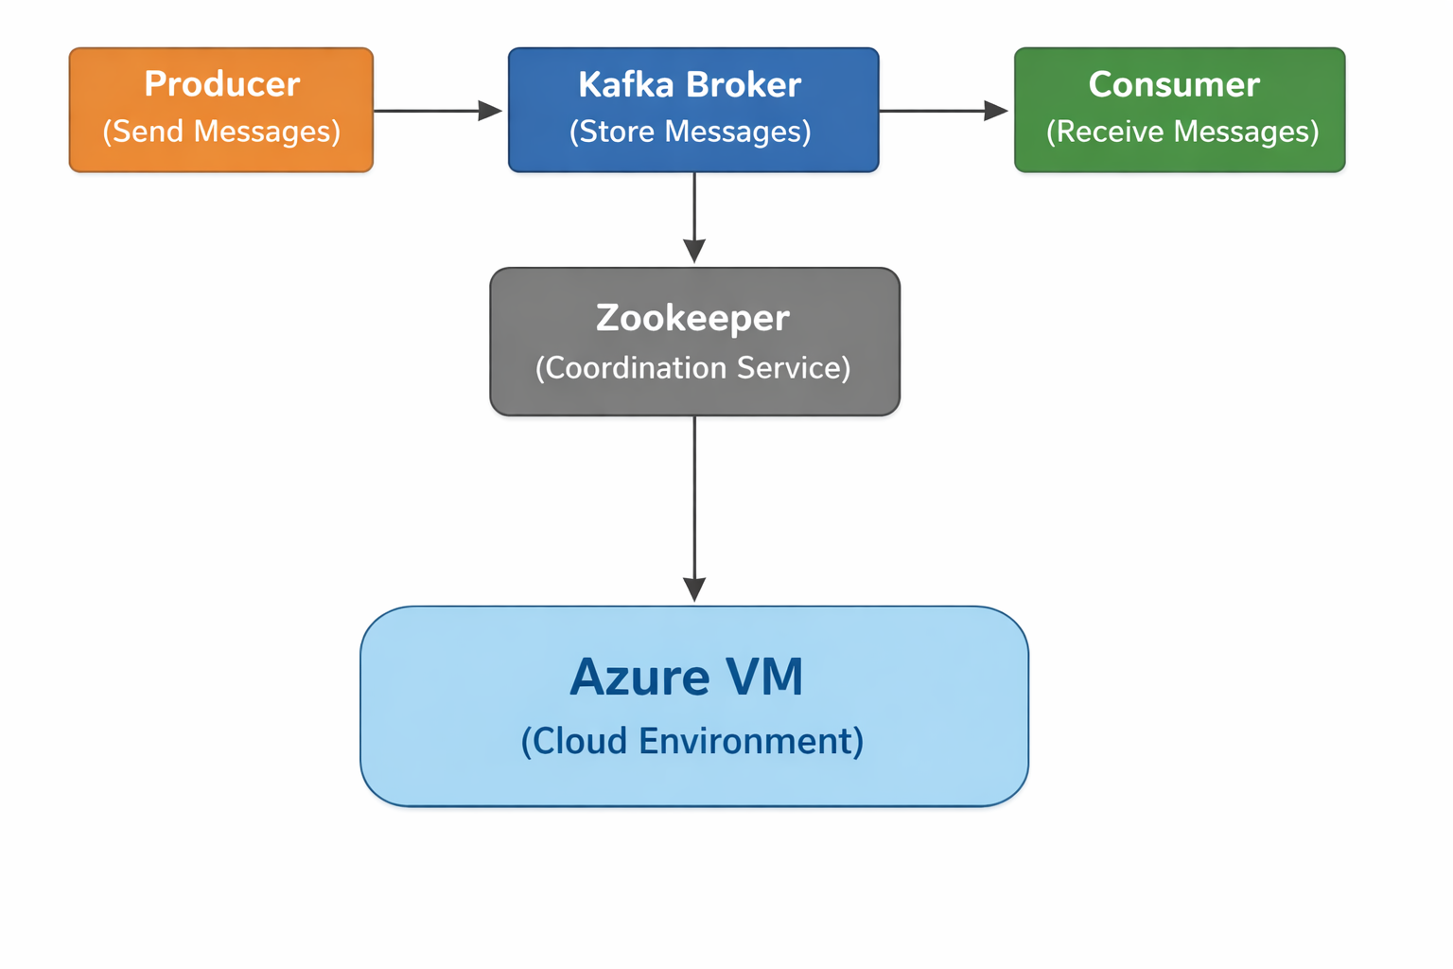
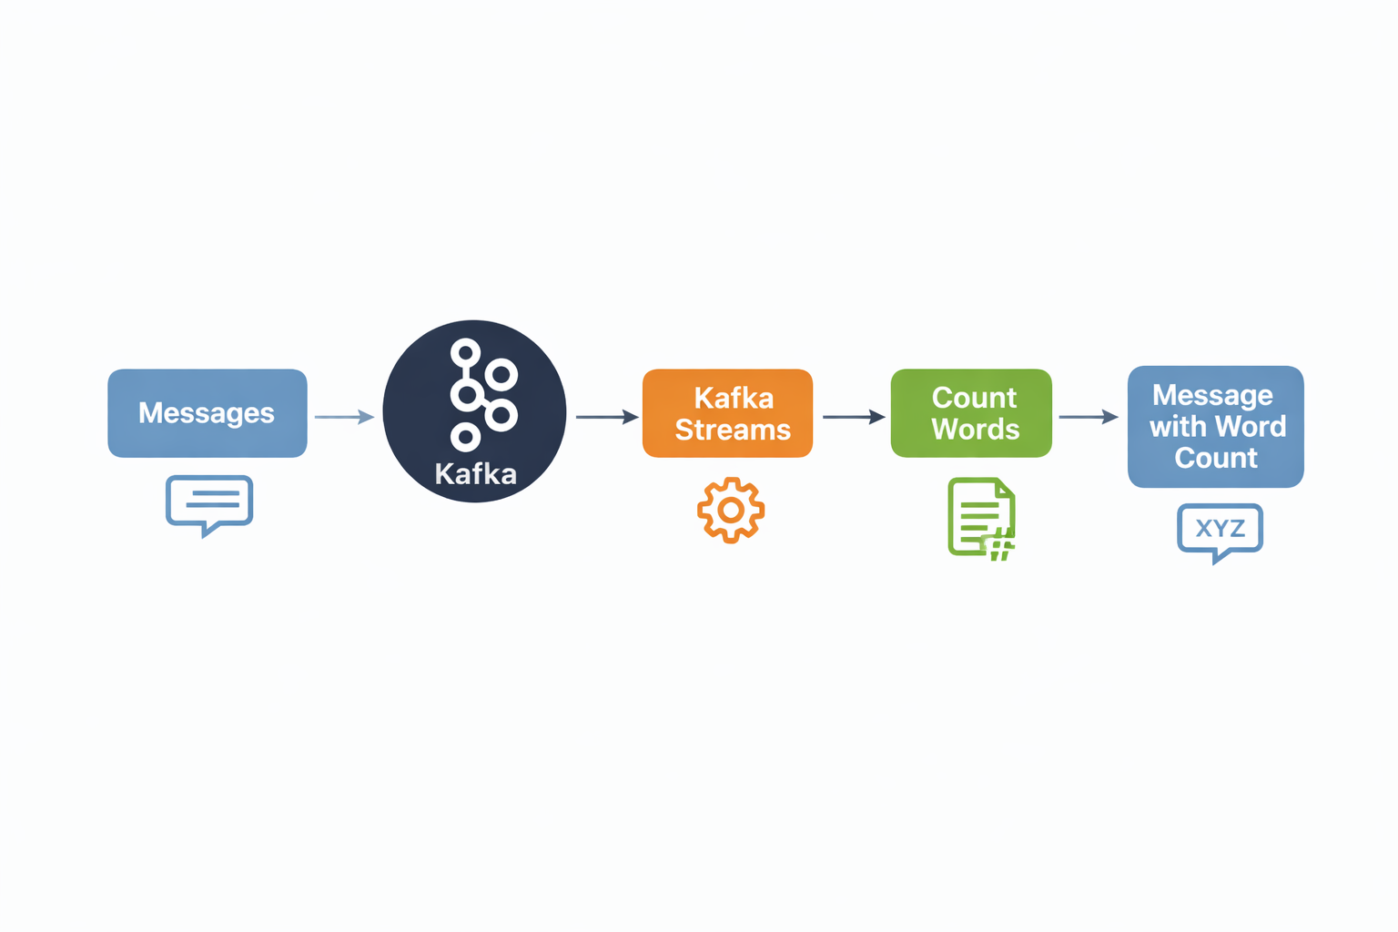

1.Azure Portal
- Login to Microsoft Azure Portal
- Navigate to Virtual Machines section

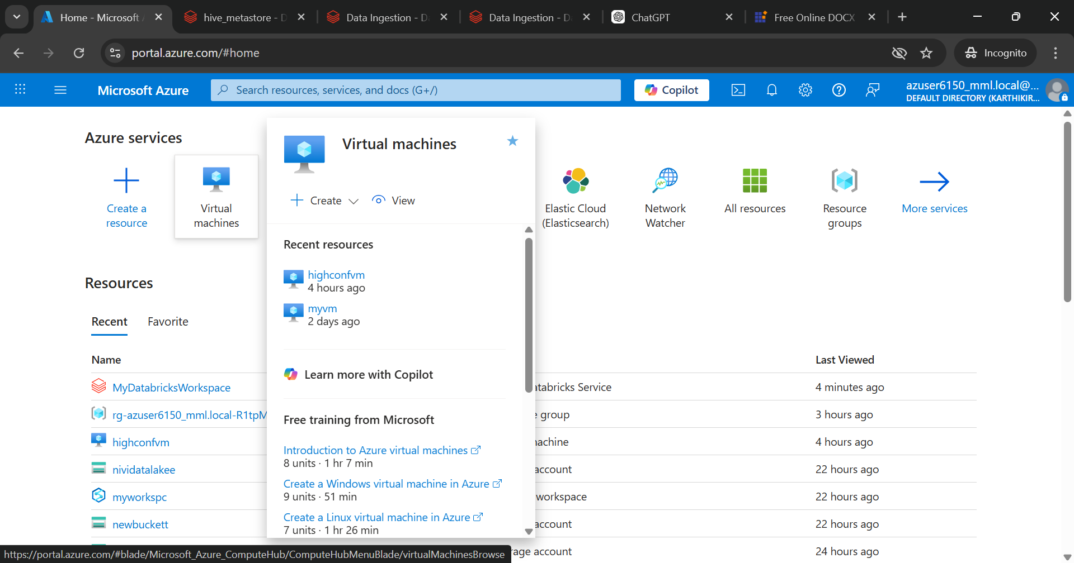

2.Virtual Machines Page
- Open Virtual Machines service
- Click on “Create”

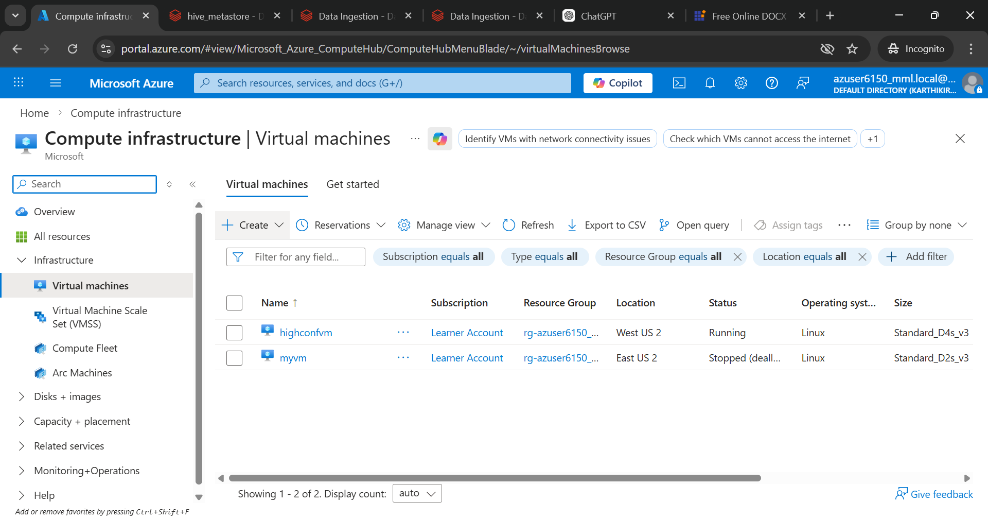

3.Basic Details
- Enter subscription and resource group
- Provide Virtual Machine name
- Select operating system (Linux/Ubuntu)
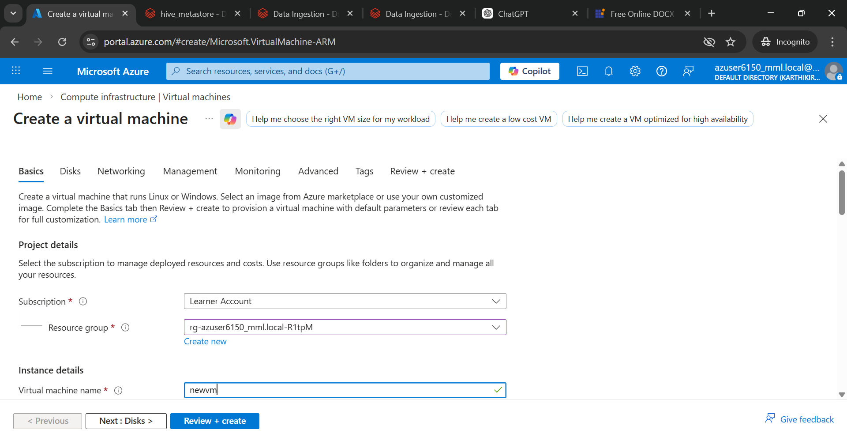

4. Region & Availability
- Choose deployment region
- Select availability options (Availability Zone)
- Choose security type standard

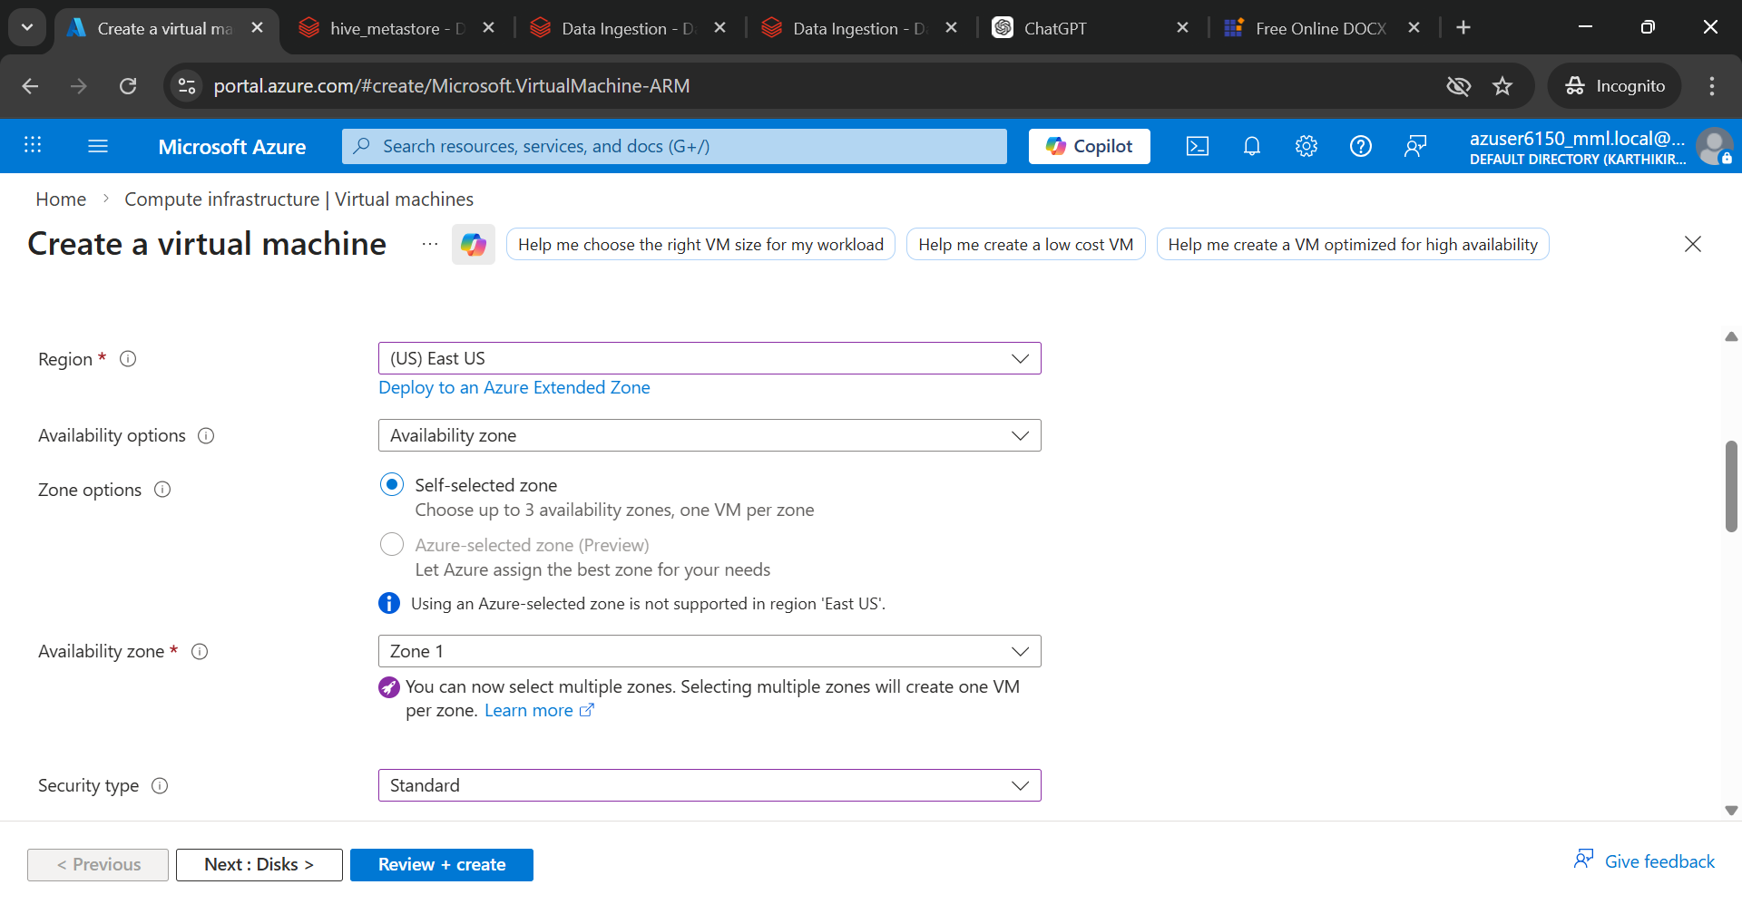

5: Size & Authentication
- Select Virtual Machine size (16gb or greater)
- Choose authentication type (SSH)
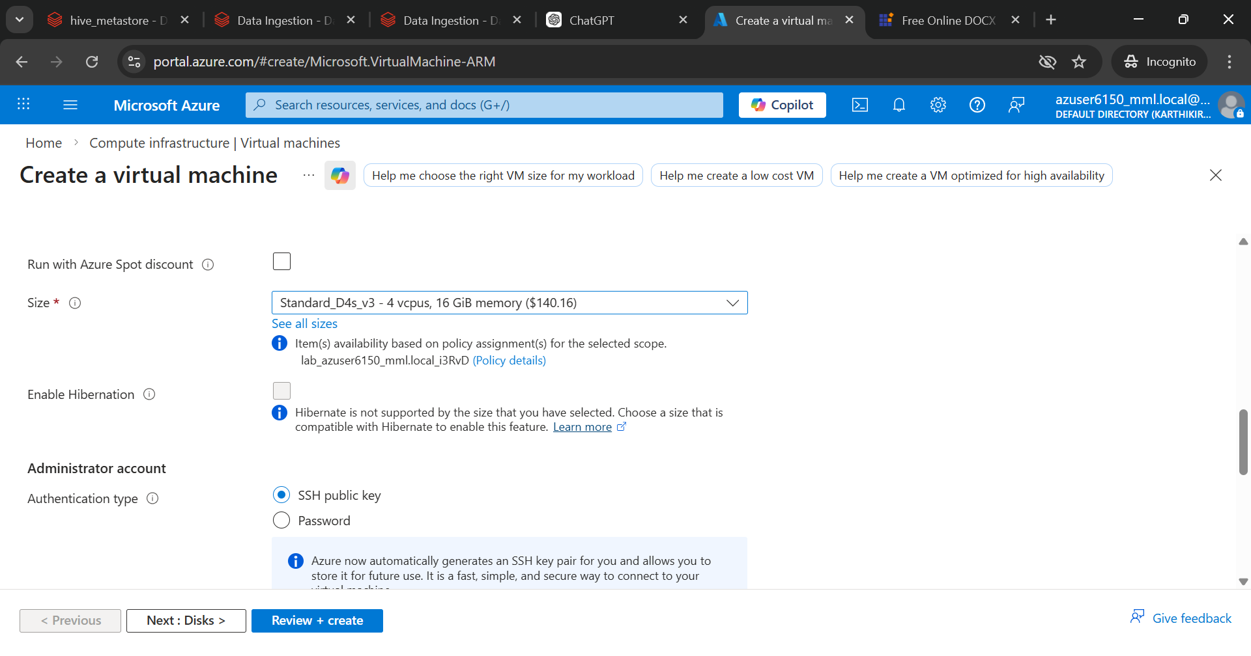

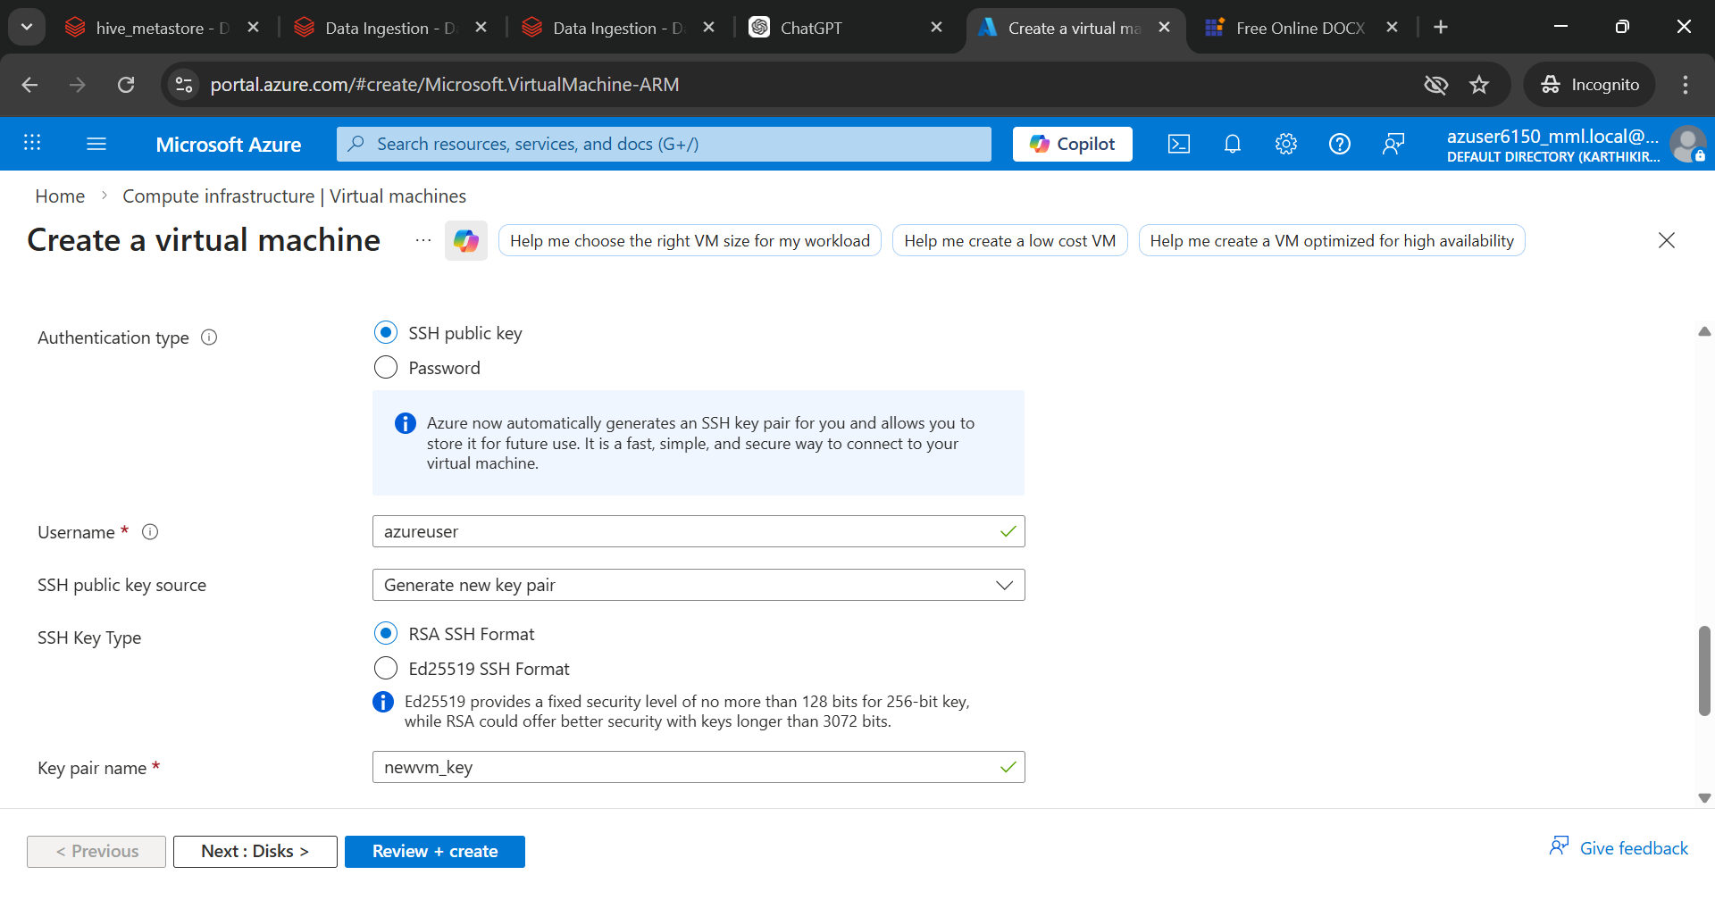

Click next and choose 64gb as disk size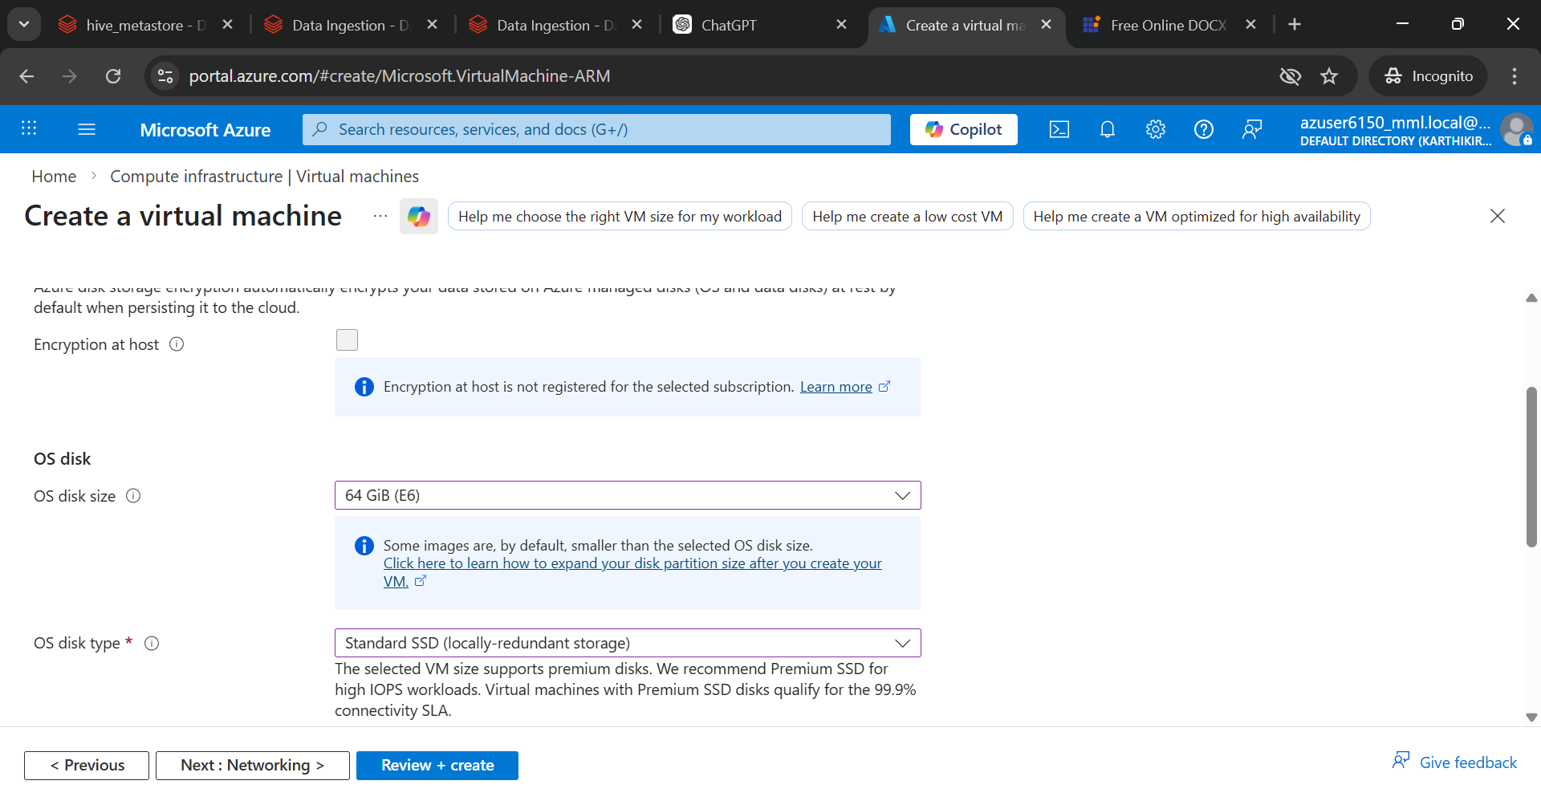

6.Review + Create
- Review all configuration details
- Click on “Create” button
- Wait for deployment to complete

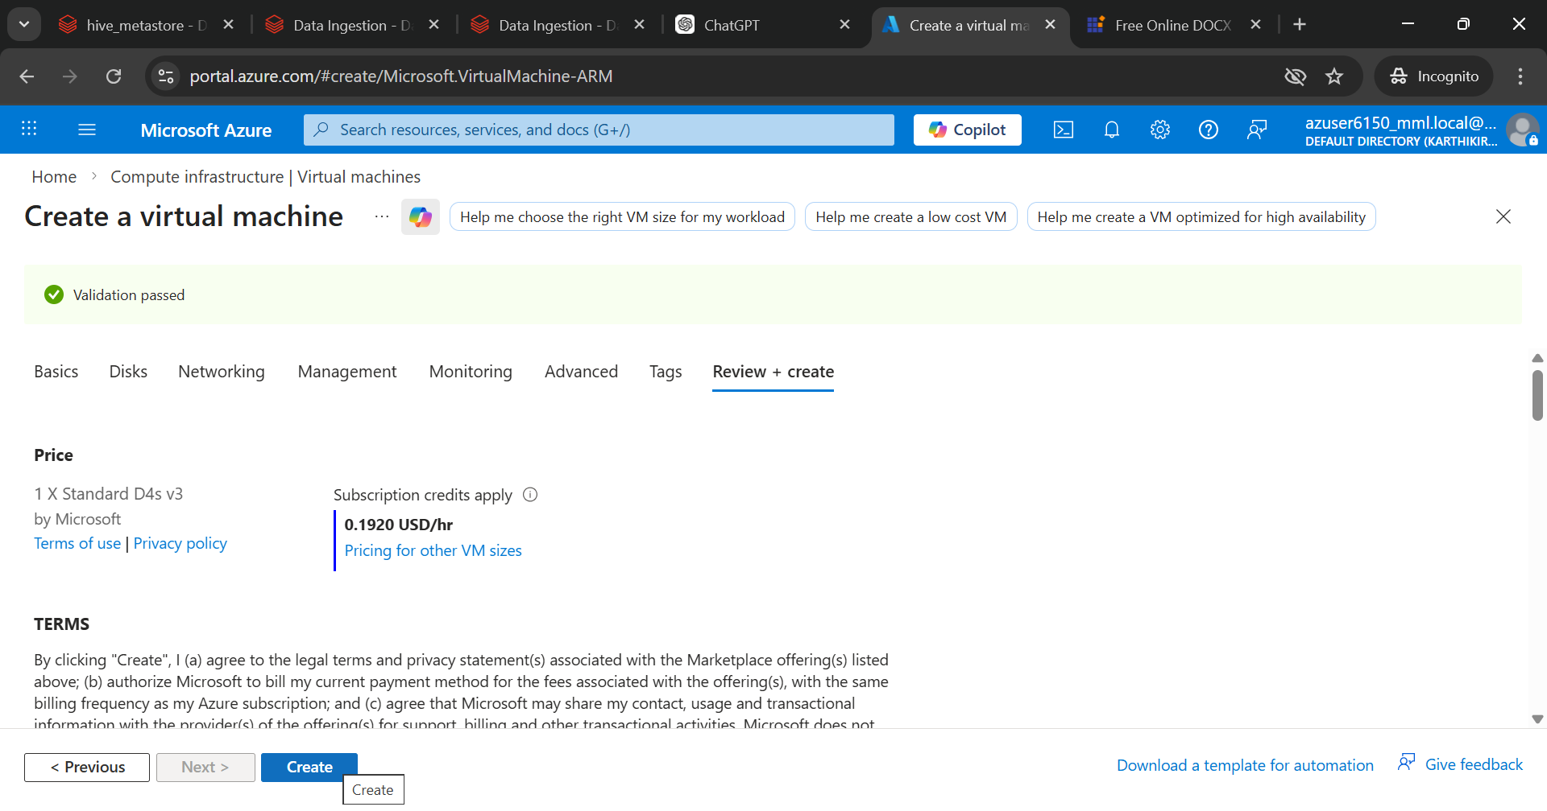

Download the file

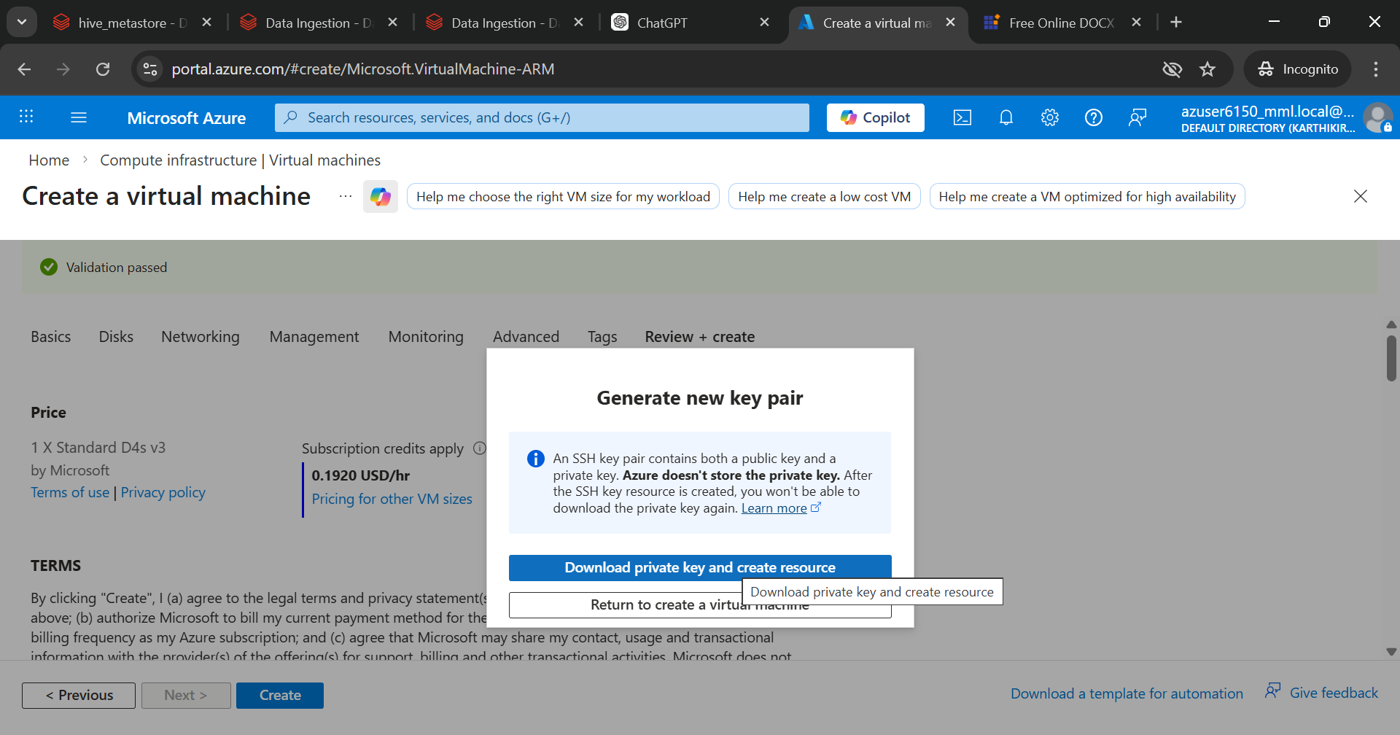

Click on go to resource

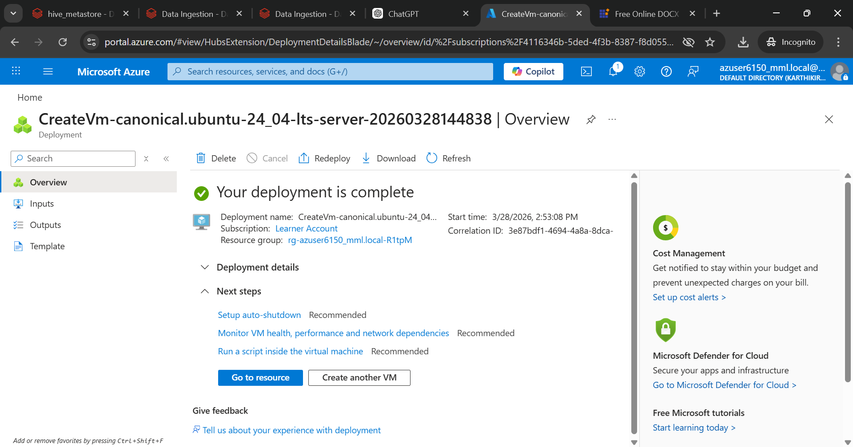

Click Connect

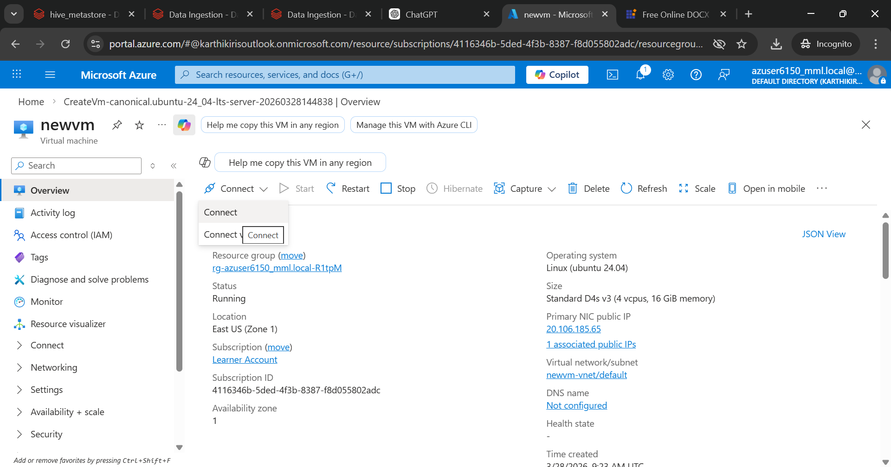

Click on configure JIT +Request access and copy the SSH command and click the icon near copilot near searchbar

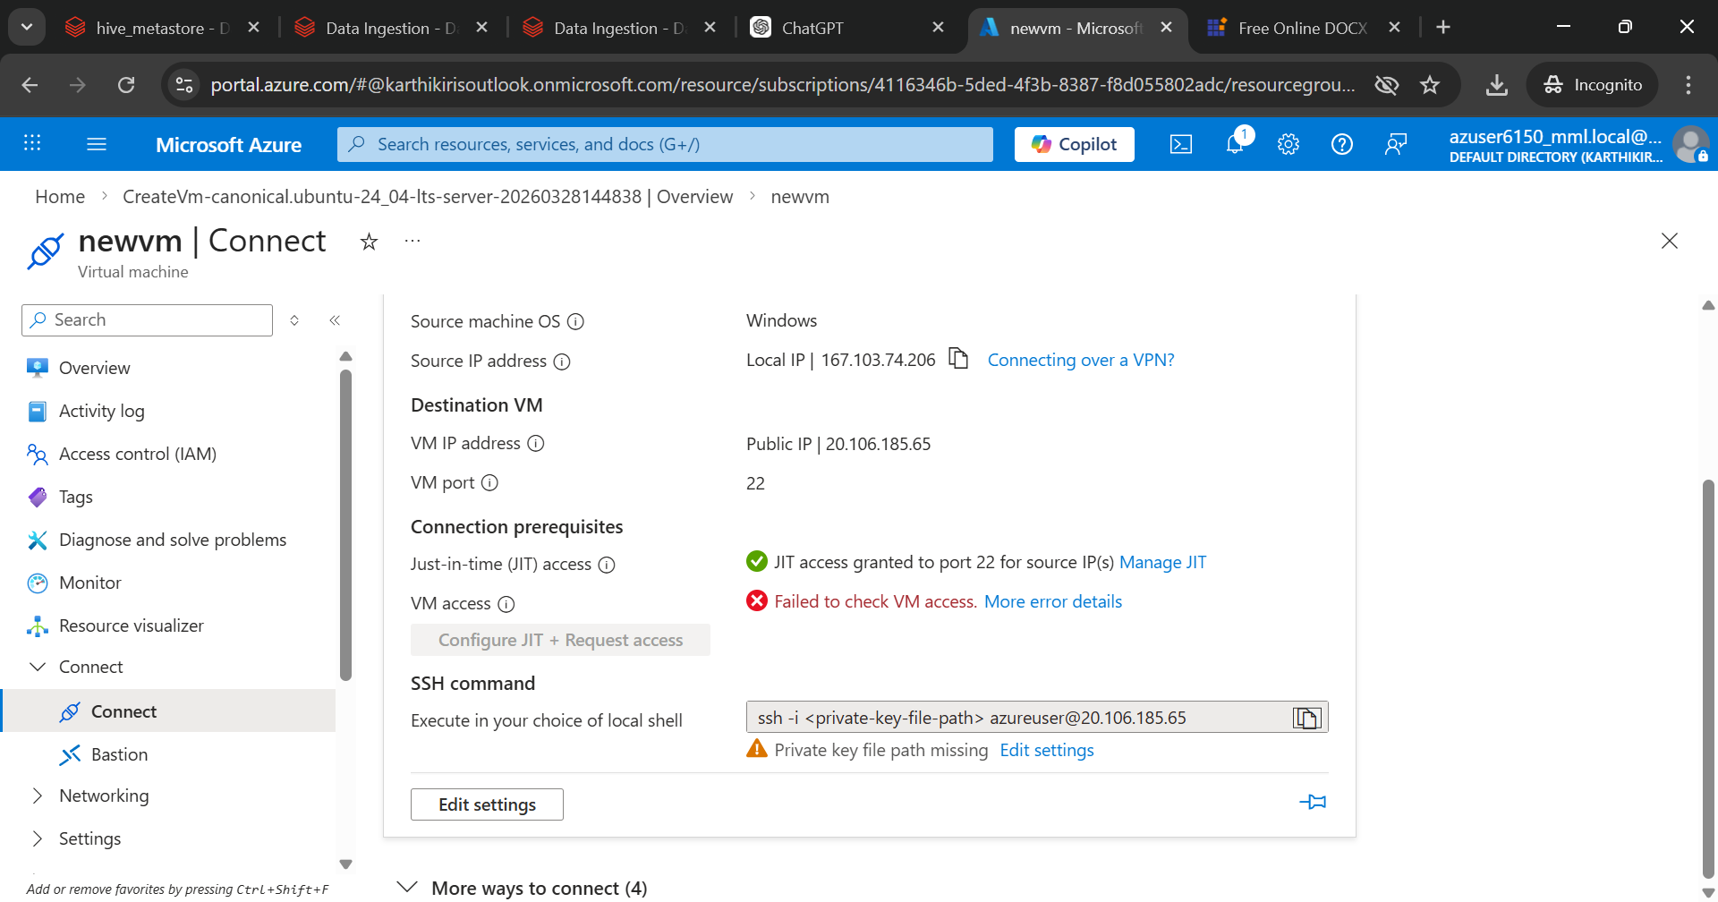

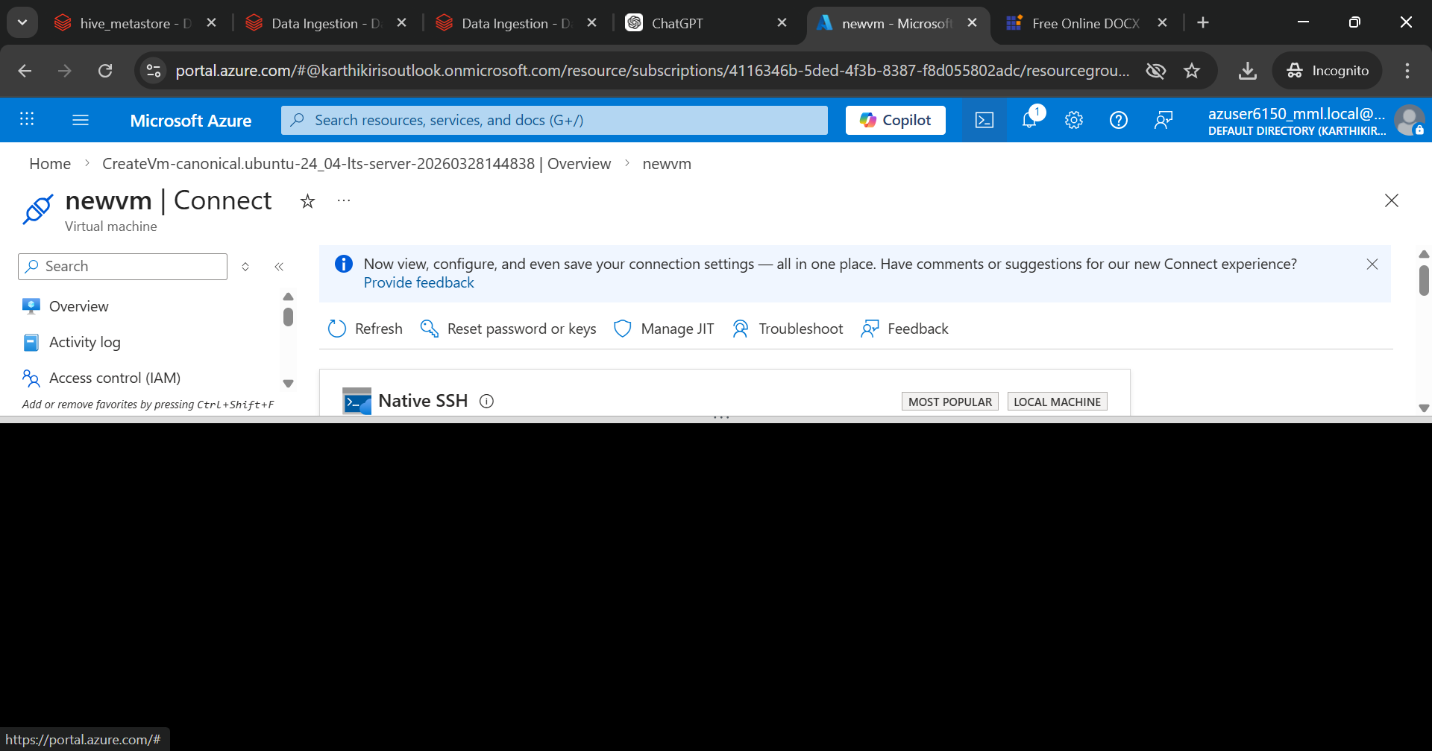

Upload the downloaded file here
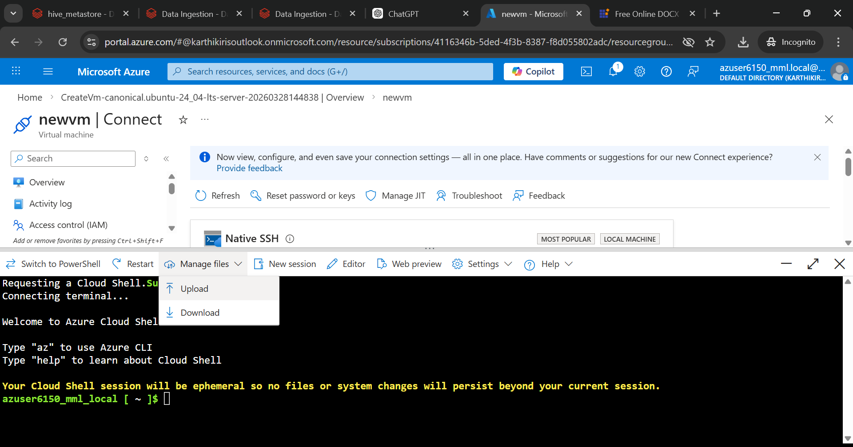

Change the permission to the uploaded file and paste the SSH command copied earlier
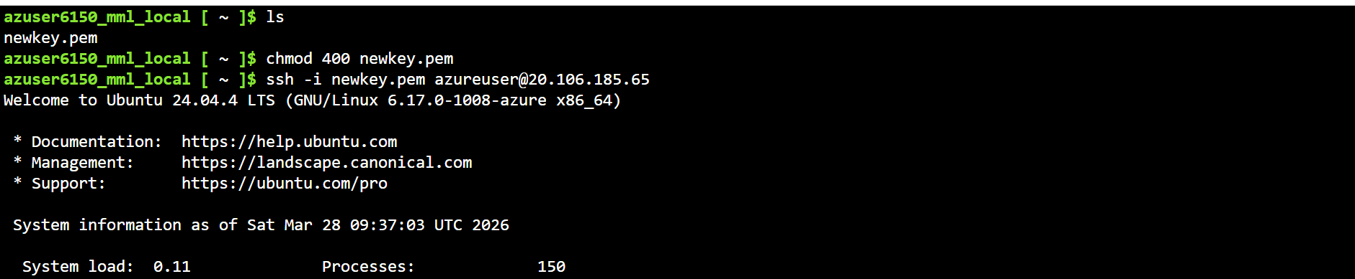

Kafka Setup
- Download Apache Kafka
- Extract Kafka files
- Navigate to Kafka directory
commands:
wget https://archive.apache.org/dist/kafka/2.8.0/kafka_2.13-2.8.0.tgz
tar -xvf kafka_2.13-2.8.0.tgz
cd kafka_2.13-2.8.0

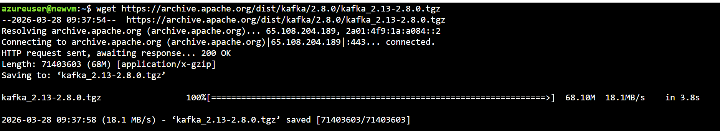

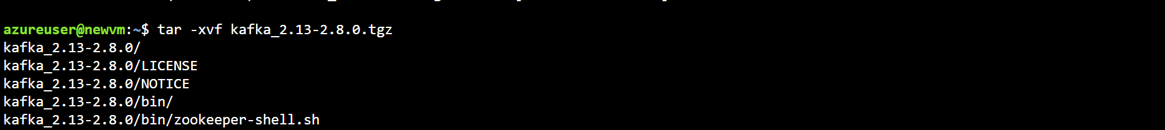

Install Java (recommended: OpenJDK 11 or 17)
sudo apt install openjdk-11-jdk -y
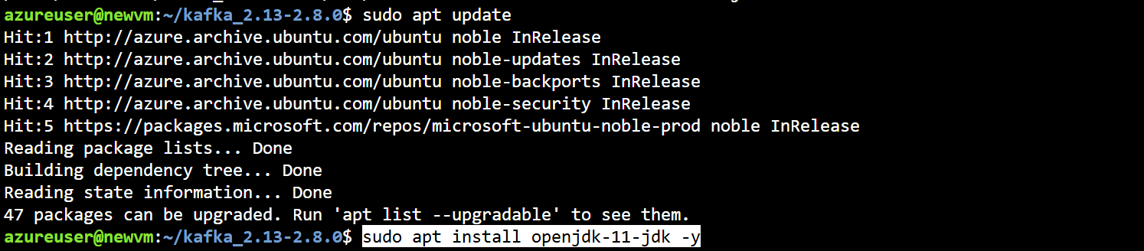

Start Zookeeper
- Run Zookeeper command
- Initialize coordination service
command: bin/zookeeper-server-start.sh config/zookeeper.properties

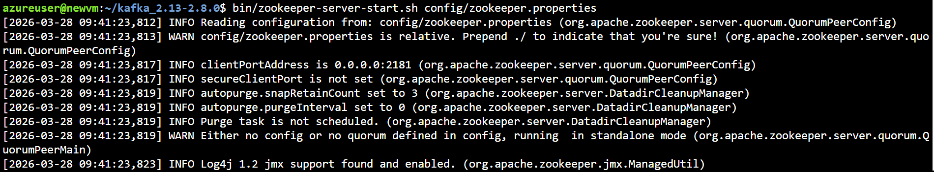

Start Kafka Server (new Terminal)
Command : bin/kafka-server-start.sh config/server.properties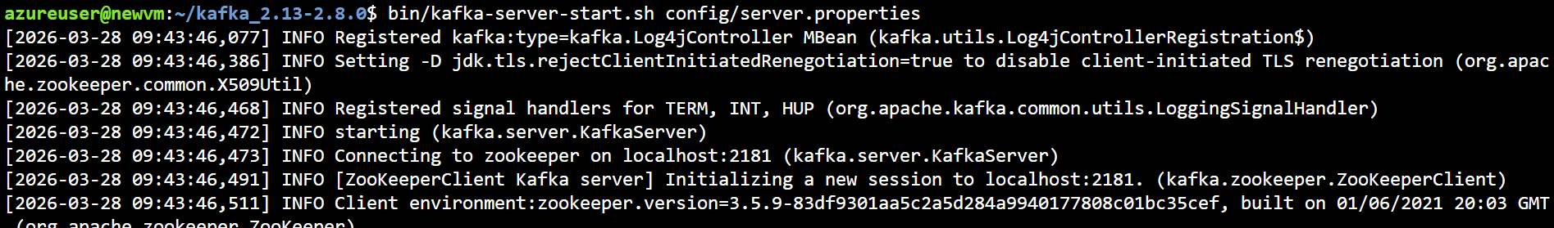

Create a Topic(New Terminal)

Command:

bin/kafka-topics.sh --create \
--topic wc \
--bootstrap-server localhost:9092 \
--partitions 1 \
--replication-factor 1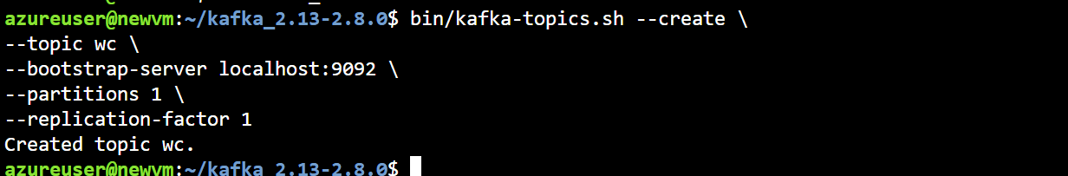

Start Producer (Same terminal as producer)
Command:

bin/kafka-console-producer.sh \
--topic wc \
--bootstrap-server localhost:9092
Type messages:
hello kafka
this is streaming
hello world
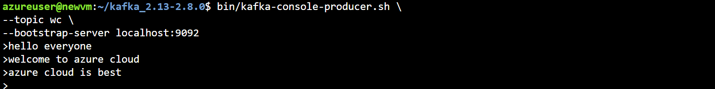

Start Consumer (New Terminal)
Command :
bin/kafka-console-consumer.sh --topic wc --bootstrap-server localhost:9092 \
| awk '{for(i=1;i<=NF;i++) words[tolower($i)]++} {for(w in words) print w, words[w]; print "----"}'

